Azure Load-Balanced Auto-Healing Web Tier
An auto-healing, load-balanced NGINX web tier on Azure, built with Bicep. Losing any single VM instance, or an entire Availability Zone, does not cause downtime.
Design decisions
- Azure used as familiarity with Azure supersedes AWS and Azure automatically spreads VM or compute across multiple Availability Zones when zones are specified on the compute resource itself. AWS subnets are pinned to a single Availability Zone at creation, so the equivalent AWS design would have required a separate subnet per zone, extra design work this Azure approach avoids.
- Terraform is the brief's stated preference, and Bicep is explicitly listed as an allowed alternative. I chose Bicep because I have more experience with bicep though I am currently building my skills around Terraform and AWS in order to be more vendor neutral.
- Maximum of three instances set so at all times if one device fails or zone fails, there are two instances managing load. Cost per added instance is comparably small compared to the potential impact of a single point of failure.
- East Australia zone set for testing deployment as certain Azure zones have only two availability zones compared to the maximum three available in some Azure zones.
- No CPU-based auto-scaling added to the solution. Scaling or self-repair only happening in the case of a failure.
- All compute sits in a single VNet / single subnet (10.0.0.0/16 / 10.0.1.0/24). Zone redundancy is configured on the VMSS itself, not the network layer.
- Single VNet and subnet used for this scenario as in Azure, subnets are region-scoped, not zone-scoped, allowing for a single subnet across the three zones within the same region, meeting the requirements of this build.
- A “rolling upgrade” policy used as opposed to a manual of fully automatic one. This allows for a staggered reboot etc during updates. With three instances, a 34% batch size resolves to exactly one instance per batch regardless of how the platform rounds the percentage internally (34% of 3 = 1.02).
- A simple NGINX Linux image used to show operation. No custom build etc. Authentication requirements (such as password minimum and maximum length and complexity) not hardcoded either. A deliberate simplification for this task's scope. In a production build I'd switch to SSH key-based authentication or at the least, a hardcoded minimum password and username complexity.
- No DNS or TLS/HTTPS is configured; the load balancer serves plain HTTP on port 80 for simplicity. For production, this would require a more secure connection.
- The design exceeds the estimated 20-dollar cap because of the cost of the Standard load-balancer (Basic would have been free, but appear to be deprecated on Azure) and the additional instance of 1 (3 instances for reliability). VNET in Azure are free

Architecture
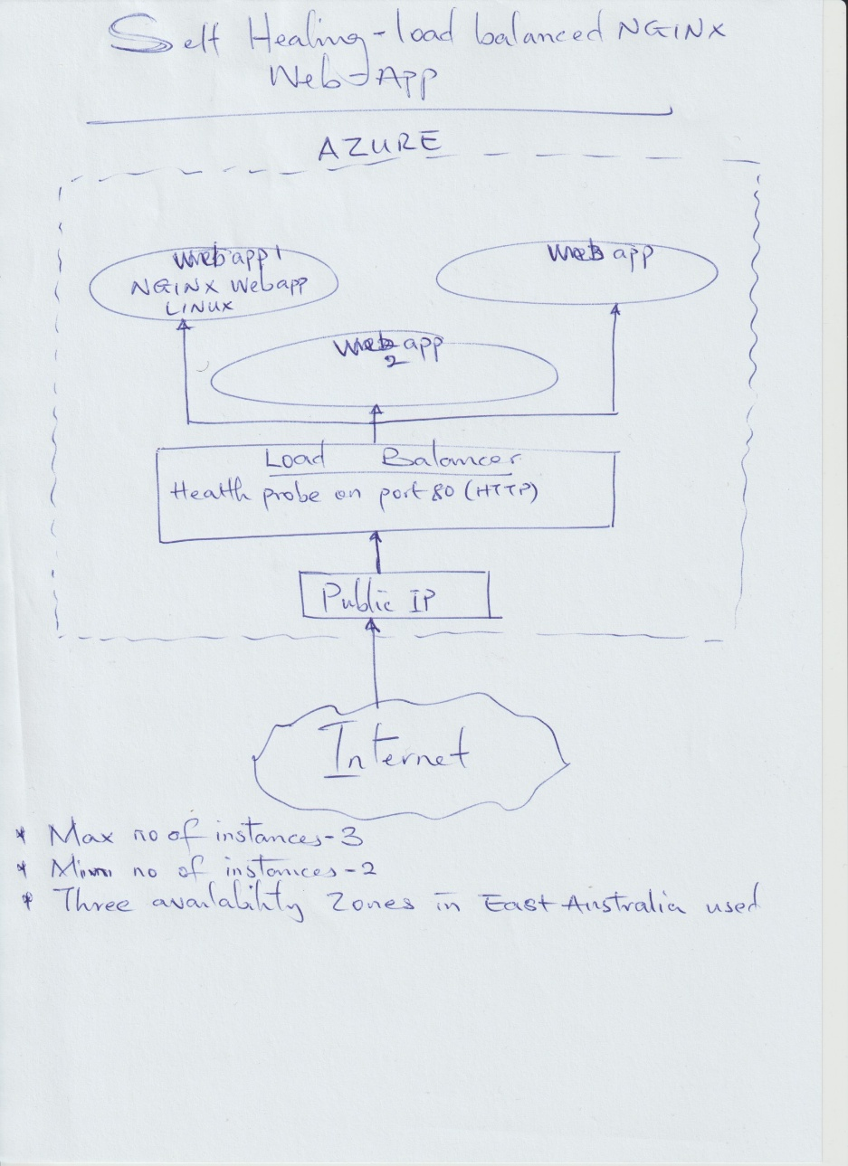
Shown in the hand-drawn image.
How to run
In PowerShell, ensure
- Log in to Azure (az login)
- Create a Resource Group where the deployment will go (az group create --name [RG-name] --location [Azure Region])
- Validate the script using what-if (az deployment group what-if --resource-group [RG-name] --template-file main.bicep --parameters adminUsername=[Adminisytrator Username] adminPassword= [‘Administrator Password’])
To actually deploy (optional — not required for review)
- Assumption - username and password = “azureadmin” and “TempP@ssw0rd2026!”
- Assumption - Standard_B1s is sufficient for a static welcome page; this is not a performance-tuned SKU choice.
- Resource group for deployment needs to be created in Azure prior to deploying. Alternatively, RG creation could be hardcoded to the scripts, but this was not included.

Output for validation
- “What-if.txt’ output exported which missed an issue with a missing health probe. Deployment caught this and was resolved. Rolling upgrade mode needs the VMSS to directly reference a health probe via “networkProfile.healthProbe”, not just have one exist on the load balancer. This only surfaced on the actual deploy attempt, confirming what-if validates structure but not every runtime business rule. Fixed by adding a “healthProbeId” parameter through the compute module.
- Two files “deploy-run1.txt” and “deploy-run2.txt” following two identical deployment runs exported to show idempotency.
- Screenshot of the connected NGINX web-app attached.

Repository structure
- GitHub\azure-load-balanced-auto-healing-web-tier
  - main.bicep
  - modules
    - compute
      - compute.bicep
    - load-balancer
      - load-balancer.bicep
    - networking
      - network.bicep
  - .gitignore
  - README.md
  - deploy-run1.txt
  - deploy-run2.txt
  - whatif-output.txt
  - other temporary files
Estimated monthly cost
Figure: NGINX web app connected

